Content Based Recommendation System
Content-Based Filtering is a recommendation technique that suggests items to a user based on the user’s own preferences and past behavior, not on what other users like.

Core Idea
- Look at items a user liked in the past
- Understand the features (content) of those items
- Recommend similar items based on those features

Real-World Example: Movie Recommendation 🎬
Step 1: Item Content (Features)
Each movie is described using features such as:
- Genre
- Actors
- Director
- Keywords
Movie | Genre | Keywords
Inception | Sci-Fi | dream, mind, thriller
Interstellar | Sci-Fi | space, time, science
Titanic | Romance | love, ship, tragedy

Advantages ✅
- Personalized recommendations
- No need for other users’ data
- Works well for new items

Disadvantages ❌
- Over-specialization (keeps recommending similar items)
- Hard to recommend something totally new
- Requires good item metadata

TD-IDF
TF-IDF is a numerical technique used in text mining and recommender systems to measure how important a word is in a document relative to a collection of documents.
👉 Important words appear often in a document but not in many other documents.

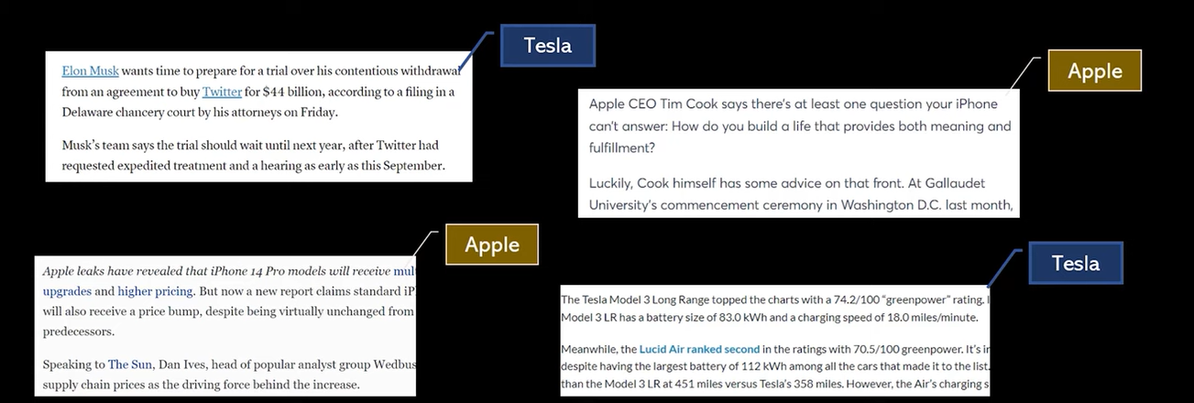

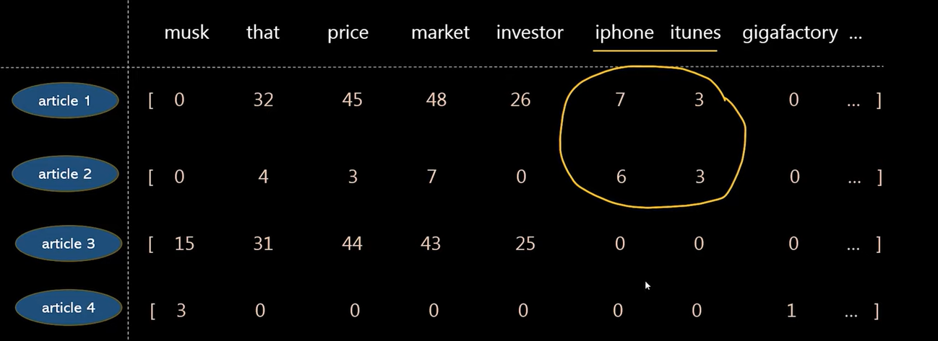

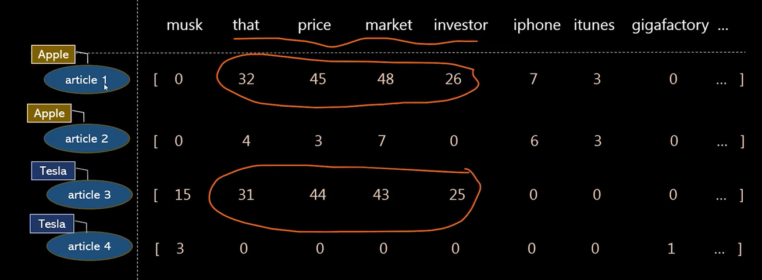
Why TF-IDF is Needed
Common words like:
the, is, and, of
appear everywhere → not useful
Rare but meaningful words like:
python, security, recommendation
→ very useful
TF-IDF reduces the weight of common words and boosts important ones.

TF-IDF = TF × IDF

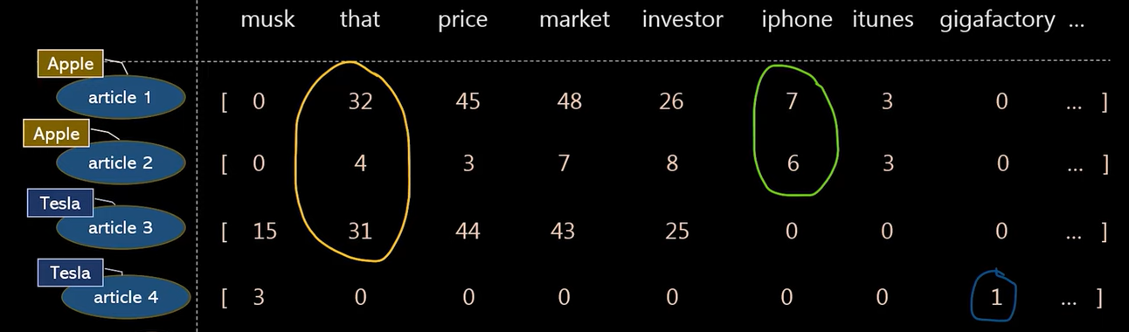

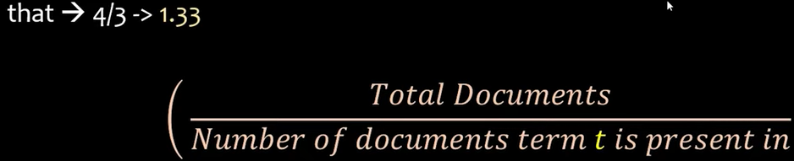

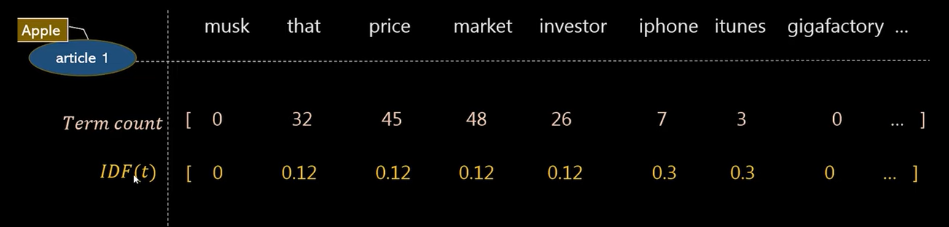

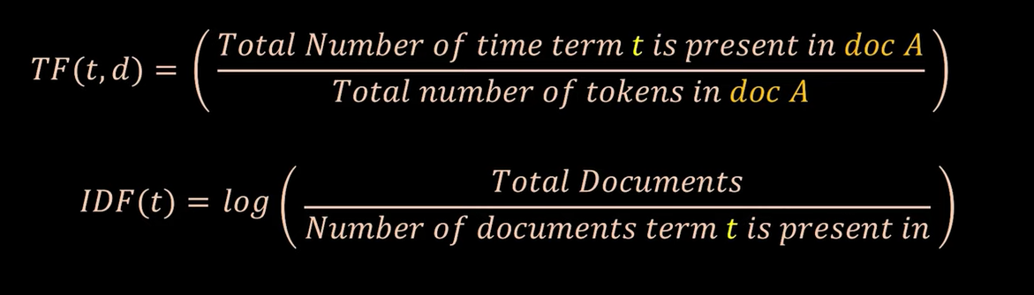

1️⃣ Term Frequency (TF)
Measures how often a word appears in a document.
Formula:
$$TF(t,d)=\frac{\text{count of term t in document d}}{\text{total words in document d}}$$
Example:
Document:
“python python developer”
- TF(python) = 2 / 3
- TF(developer) = 1 / 3

2️⃣ Inverse Document Frequency (IDF)
Measures how rare a word is across all documents.
Formula:
$$IDF(t)=log⁡\left(\frac{N}{1+df(t)}\right)$$
Where:
- N = total number of documents
- df(t) = number of documents containing term t
Example:
If:
- Total documents = 10
- “python” appears in 8 documents
- “kubernetes” appears in 1 document
Then:
- IDF(python) → low
- IDF(kubernetes) → high

3️⃣ TF-IDF Score
$$TF\text{-}IDF(t,d)=TF(t,d)×IDF(t)$$
Interpretation:
- High TF + High IDF → important word
- High TF + Low IDF → common word
- Low TF → less important

Simple End-to-End Example 📄
Documents:
- "python developer backend"
- "python developer machine learning"
- "frontend react developer"
Word Importance in Document 2:
- python → common → lower score
- machine → rare → higher score
- learning → rare → higher score
So TF-IDF highlights:
✅ machine, learning
❌ python
3/2 = 1.5 3/1 = 3 3/1

1/3 ¼ ¼

How TF-IDF Is Used in Content-Based Filtering
- Convert item descriptions into TF-IDF vectors
- Compare vectors using cosine similarity
- Recommend most similar items

Step 1️⃣ Convert Item Descriptions into TF-IDF Vectors
Example: Movie Descriptions 🎬
Movie | Description
M1 | "action superhero ironman marvel"
M2 | "action superhero thor marvel"
M3 | "romantic love story"
Using TF-IDF, each movie becomes a numeric vector:
Word | ironman | thor | action | superhero | marvel | romantic | love
M1 | 0.6 | 0.0 | 0.3 | 0.3 | 0.3 | 0.0 | 0.0
M2 | 0.0 | 0.6 | 0.3 | 0.3 | 0.3 | 0.0 | 0.0
M3 | 0.0 | 0.0 | 0.0 | 0.0 | 0.0 | 0.7 | 0.7
📌 Words that are important and rare get higher values.

Step 2️⃣ Compare Vectors Using Cosine Similarity
Cosine similarity measures how close two vectors are, ignoring length.
$$\text{cosine similarity}=\frac{A⋅B}{∣∣A∣∣∣∣B∣∣}$$
Similarity Scores:
- Similarity(M1, M2) → High (same genre & keywords)
- Similarity(M1, M3) → Low (completely different topics)
📌 Angle between vectors:
- Small angle → similar items
- Large angle → different items

Step 3️⃣ Recommend Most Similar Items
User Scenario 👤
User watched and liked:
- M1: Ironman movie
System:
- Takes M1’s TF-IDF vector
- Computes similarity with all other movies
- Sorts by similarity score
Recommendation:
Movie | Similarity
M2 (Thor) | 0.92 ✅
M3 (Romance) | 0.05 ❌
👉 Recommend Thor, not Romance

Cosine Similarity Formula
$$\text{cosine similarity}=\frac{A⋅B}{∣∣A∣∣ ∣∣B∣∣}$$
Where:
- A · B = dot product (overlap of words)
- ||A|| = length (magnitude) of vector A
- ||B|| = length of vector B

Intuition (Most Important Part 💡)
Think of vectors as arrows 📐
- Same direction → very similar → cosine ≈ 1
- 90° angle → unrelated → cosine ≈ 0
- Opposite direction → very different → cosine ≈ −1 (rare in TF-IDF)

Step-by-Step Numeric Example
Compare M1 (Ironman) and M2 (Thor)
Vectors
M1 = [0.5, 0.5, 0.7, 0.0]
M2 = [0.5, 0.5, 0.0, 0.0]
1️⃣ Dot Product
(0.5×0.5) + (0.5×0.5) + (0.7×0) + (0×0)
= 0.25 + 0.25
= 0.50
2️⃣ Vector Lengths
||M1|| = √(0.5² + 0.5² + 0.7²) ≈ 1.01
||M2|| = √(0.5² + 0.5²) ≈ 0.71
3️⃣ Cosine Similarity
$$\frac{0.50}{1.01×0.71}≈0.70$$
✅ High similarity

Compare M1 (Ironman) and M3 (Romance)
Vectors
M1 = [0.5, 0.5, 0.7, 0.0]
M3 = [0.0, 0.0, 0.0, 0.8]
Dot Product
= 0
Cosine Similarity
$$0→\text{No overlap}$$
❌ Low similarity

Why Angle Matters (Visual Explanation)
Small angle → vectors point in same direction → similar
Large angle → vectors point apart → different
TF-IDF vectors share direction only if they share important words.

1. What does TF-IDF stand for?
A. Term Frequency – Inverse Data Frequency
B. Term Factor – Inverse Document Frequency
C. Term Frequency – Inverse Document Frequency
D. Token Frequency – Inverse Data Factor

2. What is the main purpose of TF-IDF?
A. Count total words in a document
B. Measure word importance in a document relative to a corpus
C. Reduce document size
D. Perform sentiment analysis

3. Which component of TF-IDF measures how often a word appears in a document?
A. IDF
B. Tokenization
C. TF
D. Normalization

4. How is Term Frequency (TF) typically calculated?
A. Number of documents containing the term
B. Total words in corpus ÷ total words in document
C. Number of times term appears in document ÷ total words in document
D. Log of term count

5. What happens to IDF when a word appears in many documents?
A. IDF increases
B. IDF becomes zero
C. IDF decreases
D. IDF becomes negative

6. Which word is likely to have the highest TF-IDF score?
A. A word appearing in every document
B. A rare word appearing in only one document
C. A stop word like “the”
D. A word that appears zero times

7. Why are stop words usually removed before applying TF-IDF?
A. They increase document length
B. They have low TF values
C. They have low IDF values and add little meaning
D. They increase computation speed

8. Which of the following is a limitation of TF-IDF?
A. It considers word order
B. It captures semantic meaning
C. It ignores word context and synonyms
D. It works only on small datasets

9. TF-IDF is most commonly used in which application?
A. Image classification
B. Speech recognition
C. Text similarity and information retrieval
D. Time-series forecasting

10. Which sklearn class is used to compute TF-IDF in Python?
A. CountVectorizer
B. TfidfTransformer
C. TfidfVectorizer
D. TextVectorizer

